Flowchart and Notes One

Michael Surdek
Southern New Hampshire University
DAT 690: Capstone in Data Analytics
Professor Arman Kanooni
September 4, 2022
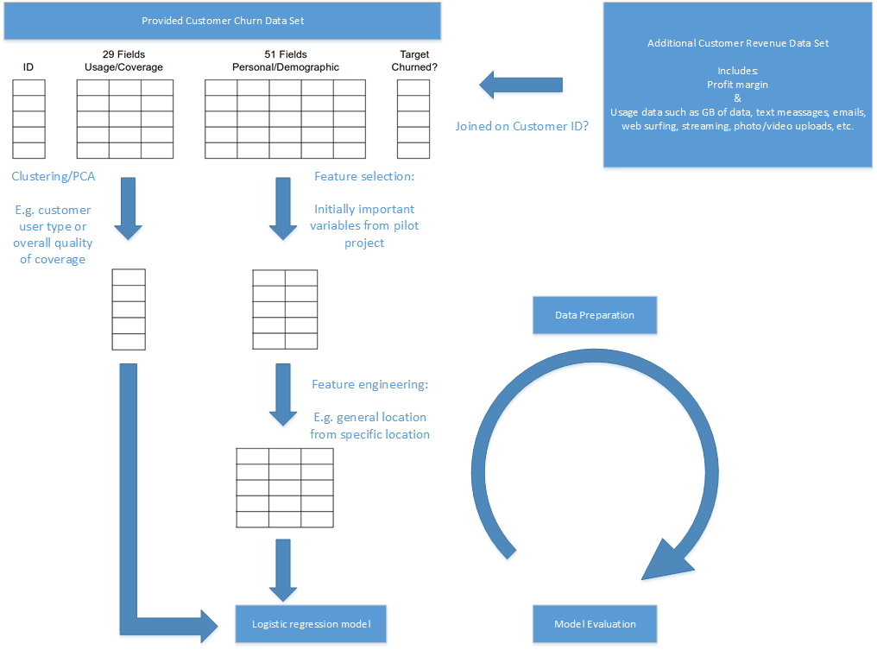
The basis of the cleaned and prepared data set that will be used to build the logistic regression model for predicting customers who will churn is the customer churn data set that has been provided. This data set contains 850 observations of over 80 variables. Approximately 30 of the fields pertain to a customer’s usage and cellular coverage, and the other 50 are their demographic and personal information. Additionally, there is a customer revenue data set that has been provided for a related business problem and includes new usage data such as gigabytes used, text messages and emails, time spent surfing the web, and uploads. Based on initial exploration, most but not all of the customers included the original data are also in the revenue data. If it is allowed and it provides additional predictive value, it may be worth it to join the data sets to prepare for the final model.
The main tasks of the data preparation, besides handling data types and missing data, are feature selection and feature engineer through either descriptive statistics such as clustering or manual transformations. For example, rather than using each of the 15-20 fields that describe a customer’s usage, cluster analysis can be performed to classify each customer as a specific type of user. It is possible that a customer’s usage classification is a better predictor of the likelihood that they will churn than any of the individual usage fields themselves. Finally, the data will be trained on a subset of the original data set. This means that the rest of the observations will be held out for the evaluation phase in order to see how well the model scales to unseen data.

